**THE PATTERNS COMPANY**

4th Floor, Bizness Square Junction Opposite Hitex Road, HITEC City, Madhapur, Hyderabad, Telangana 500084

+91-8500693113

+91-9392744210

[info@thepatternscompany.com](mailto:info@thepatternscompany.com)

https://[www.thepatternscompany.com](http://www.thepatternscompany.com/)



Website Report for [www.rksecuritysystems.co.in](http://www.rksecuritysystems.co.in/)

This report grades your website based on the strength of various SEO factors such as On Page Optimization, O Page Links, Social and more. The overall Grade is on a A+ to F- scale, with most major, industry leading websites in the A range. Improving your grade will generally make your website perform better for users and rank better in search engines. There are recommendations for improving your website at the bottom of the report. Feel free to reach out to us if you’d like us to help with improving your website’s SEO!

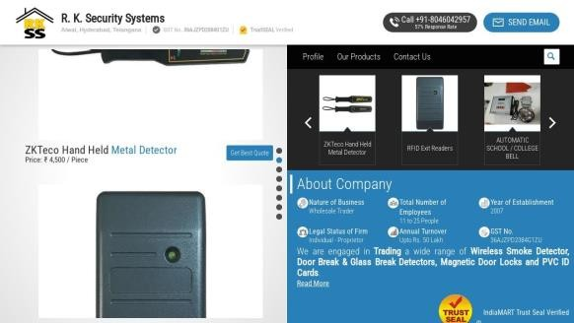

Audit Results for [www.rksecuritysystems.co.in](http://www.rksecuritysystems.co.in/)



**C+**

**Your page could be better**

Recommendations: 20

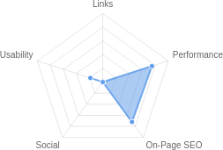

|  |  |  |  |  |
| --- | --- | --- | --- | --- |
| **B+** | **F** | **D-** | **A-** | **F** |
| On-Page SEO | Links | Usability | Performance | Social |

Recommendations

## Execute a Link Building Strategy

Links

High Priority

**Reduce length of title tag (to between 10 and 70 characters)**

On-Page SEO

Medium Priority

|  |  |  |
| --- | --- | --- |
| **Make greater use of header tags** | On-Page SEO | Medium Priority |
| **Update Link URLs to be more human and Search Engine readable** | Links | Low Priority |
| **Create and link your Facebook Page** | Social | Low Priority |
| **Create and link your Twitter profile** | Social | Low Priority |
|  |  |  |
| **Use your main keywords across the important HTML tags** | On-Page SEO | Low Priority |
|  |  |  |
| **Increase page text content** | On-Page SEO | Low Priority |
|  |  |  |
| **Make use of HTTP/2+ protocol** | Performance | Low Priority |
|  |  |  |
| **Optimize your page for Mobile PageSpeed Insights** | Usability | Low Priority |
|  |  |  |
| **Optimize your page for Desktop PageSpeed Insights** | Usability | Low Priority |
|  |  |  |
| **Add Schema Markup** | On-Page SEO | Low Priority |
|  |  |  |
| **Create and link associated Instagram profile** | Social | Low Priority |
| **Create and link an associated YouTube channel** | Social | Low Priority |
| **Setup & Install a Facebook Pixel** | Social | Low Priority |
|  |  |  |
| **Remove inline styles** | Performance | Low Priority |
|  |  |  |
| **Remove iFrames** | Usability | Low Priority |
|  |  |  |
| **Review and Increase Font Sizes across devices** | Usability | Low Priority |
|  |  |  |
| **Improve the size of tap targets** | Usability | Low Priority |
| **Improve Google Business Profile Rating & Review Count** | Other | Low Priority |

On-Page SEO Results

## Title Tag



**B+**

**Your On-Page SEO is good**

Your page is mostly optimized for On-Page SEO performance. On-Page SEO is important to ensure Search Engines can understand your content appropriately and help it rank for relevant keywords. You can continue to improve your page by ensuring HTML Tag Content is completed correctly and text content is well aligned with chosen keywords.

You have a title tag, but ideally it should be shortened to between 10 and 70 characters (including spaces).

R. K. Security Systems, Hyderabad - Wholesale Trader of Access Control Systems and CCTV Cameras Length : 95

Title tags are very important for search engines to correctly understand and categorize your content.

## Meta Description Tag

Your page has a meta description of optimal length (between 70 and 160 characters).

Wholesale Trader of Access Control Systems, CCTV Cameras & O ce Automation o ered by R. K. Security Systems from Hyderabad, Telangana, India

Length : 147

## SERP Snippet Preview

This illustrates how your page may appear in Search Results. Note, this is intended as a guide and Search Engines are more frequently generating this content dynamically.

[https://www.rksecuritysystems.co.in](http://www.rksecuritysystems.co.in/) ⋮

R. K. Security Systems, Hyderabad - Wholesale Trader of ...

Wholesale Trader of Access Control Systems, CCTV Cameras & Office Automation offered by R. K. Security Systems from Hyderabad, Telangana, India

## Hreflang Usage

Your page is not making use of Hre ang attributes.

## Language

Your page is using the lang attribute. Declared: English

## H1 Header Tag Usage

Your page has a H1 Tag.

## H2-H6 Header Tag Usage

Your page is not making use of multiple levels of Header Tags.

HTML header tags are an important way of signaling to search engines the important content topics of your page, and subsequently the keywords it should rank for.

Header Tag Frequency

H2 10

H3 0

H4 0

H5 0

H6 0

## Keyword Consistency

Your page's main keywords are not distributed well across the important HTML tags.

Your page content should be focused around particular keywords you would like to rank for. Ideally these keywords should also be distributed across tags such as the title, meta and header tags.

Individual Keywords

Keyword Title Meta Description

Tag

Headings Tags Page Frequency



quote 11



get

11

price 11



best

10

piece 8



system

8

detector 6

door 6

Phrases

Phrase Title Meta Description

Tag

Headings Tags Page Frequency



get best quote 10



best quote

10

get best 10



piece get best

8

piece get 8

based attendance    5

system



based attendance 5

attendance system    5

## Amount of Content

Your page has a low volume of text content which search engines can interpret as 'thin content'.

Word Count: 473

It has been well researched that higher text content volumes are related to better ranking ability in general.

## Image Alt Attributes

You do not have any images missing Alt attributes on your page.

## Canonical Tag

Your page is using the Canonical Tag.

https://[www.rksecuritysystems.co.in/](http://www.rksecuritysystems.co.in/)

## Noindex Tag Test

Your page is not using the Noindex Tag which prevents indexing.

## Noindex Header Test

Your page is not using the Noindex Header which prevents indexing.

## SSL Enabled

Your website has SSL enabled.

## HTTPS Redirect

Your page successfully redirects to a HTTPS (SSL secure) version.

## Robots.txt

Your website appears to have a robots.txt le.

<http://www.rksecuritysystems.co.in/robots.txt>

## Blocked by Robots.txt

Your page does not appear to be blocked by robots.txt.

## XML Sitemaps

Your website appears to have an XML sitemap.

https://[www.rksecuritysystems.co.in/sitemap.xml](http://www.rksecuritysystems.co.in/sitemap.xml)

## Analytics

Your page is using an analytics tool.



Google Analytics

## Schema.org Structured Data

We have not detected any usage of Schema.org on your page.

Schema.org is a structured data markup for webpages which helps Search Engines understand your site better and provide rich snippets directly in their search results.

Rankings

## Top Keyword Rankings

This shows your top 10 Keyword Rankings in the speci c location. The list is ordered by the keywords that drive the most tra c to your page.

Keyword Country & Language

Position Total

Searches

Estimated Tra c



cctv camera price EN 42 74,000 155

cctv camera cost in hyderabad

 EN 3 1,300 126



cctv camera price

hyderabad

HI

3

1,300

126

cctv camera price in hyderabad

 HI 3 1,300 126



cctv camera price in india

hyderabad

EN

3

1,300

126

ap tracker  HI 9 6,600 99



cctv camera price

hyderabad

EN

4

1,300

85

ap tracker  EN 10 6,600 74



mining gps EN 5 880 41

ap mines  HI 31 18,100 38

## Total Traffic From Search

This shows you the Estimated Tra c Volume your page receives from it’s Keyword Rankings



**1,383**

Monthly Tra c Volume

## Keyword Positions

This shows you a summary of the positions for your Keyword Rankings. The higher you rank, the more likely you are to capture tra c, with recent research showing that as much as 92% of clicks happen on the rst page.

Position Keywords

Position 1 0

Position 2-3 4

Position 4-10 19

Position 11-20 14

Position 21-30 13

Position 31-100 86

Links

## Backlink Summary

You have a reasonably weak level of backlink activity to this page.

Search Engines use backlinks as a strong indicator of a page's authority, relevance and ranking potential. There are various strategies available to gain links to a page to improve this factor



**5**



**1**

Domain Strength

Page Strength



**66**

Backlinks

**7**

Referring Domains

|  |  |  |  |  |  |
| --- | --- | --- | --- | --- | --- |
| **11**  Nofollow Backlinks | **55**  Dofollow Backlinks | **0**  Edu Backlinks | **0**  Gov Backlinks | **19**  Subnets | **19**  IPs |

## Top Backlinks

These are the highest value external pages we have found linking to your site.

Domain strength

Referring Page URL

90 https://dir.indiamart.com/hyderabad/card-access-system.html

90 https://[www.indiamart.com/company/4732483/](http://www.indiamart.com/company/4732483/)

84 https://[www.followala.com/products/Radiometric-Detectors/](http://www.followala.com/products/Radiometric-Detectors/)

75 https://[www.sitelike.org/similar/accuranetwork.com/](http://www.sitelike.org/similar/accuranetwork.com/)

74

https:/[/www.websitescrawl.com/domain-list-18692](http://www.websitescrawl.com/domain-list-18692)

9 https:/[/www.wholesale-distributor.com/cctv-camera-wholesale/](http://www.wholesale-distributor.com/cctv-camera-wholesale/)

0 https://bedroom.nazilah.me/car-gps-tracker-hyderabad.html

## Top Pages by Backlinks

These are the pages on your site with the most the backlinks from other sites.

URL Backlinks

https://[www.rksecuritysystems.co.in/](http://www.rksecuritysystems.co.in/) 54

<http://www.rksecuritysystems.co.in/> 6

<http://rksecuritysystems.co.in/> 1

https://[www.rksecuritysystems.co.in/?pos=3&pla=n](http://www.rksecuritysystems.co.in/?pos=3&pla=n) 1

https://[www.rksecuritysystems.co.in/cctv-cameras.html](http://www.rksecuritysystems.co.in/cctv-cameras.html) 1

https://[www.rksecuritysystems.co.in/](http://www.rksecuritysystems.co.in/)  re-alarm-control-panel.html 1

https://[www.rksecuritysystems.co.in/pir-motion.html](http://www.rksecuritysystems.co.in/pir-motion.html) 1

https://[www.rksecuritysystems.co.in/smoke-detector.html](http://www.rksecuritysystems.co.in/smoke-detector.html) 1

## Top Anchors by Backlinks

These are the top pieces of Anchor Text we found used to link to your site.

Anchor Backlinks

R. K. Security Systems 40

Alwal, Hyderabad, Telangana, India 8

rksecu[ritysystems.co.in](http://www.rksecuritysystems.co.in/) 8

https:/[/www.rksecuritysystems.co.in](http://www.rksecuritysystems.co.in/) 6

More L[ike This](http://www.rksecuritysystems.co.in/cctv-cameras.html) 3

https://[www.rksecuritysystems.co.in/cctv-cameras.html](http://www.rksecuritysystems.co.in/cctv-cameras.html) 1

## Top Referring Domain Geographies

These are the Top Geographies we have found linking to your site.

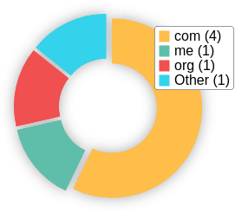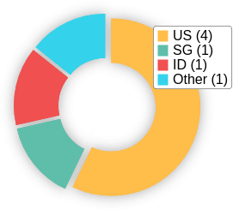Top TLDs Top Countries

## On-Page Link Structure

We found 112 total links. 6% of your links are external links and are sending authority to other sites. 0% of your links are nofollow links, meaning authority is not being passed to those destination pages.

## Friendly Links

Some of your link URLs do not appear friendly to humans or search engines.

We would recommend making URLs as readable as possible by reducing length, le names, code strings and special characters.

# Usability

## Your usability needs improvement



**D-**

Your page has usability issues across devices. Usability is important to maximize your available audience and minimize user bounce rates (which can indirectly a ect your search engine rankings).

## Device Rendering

This check visually demonstrates how your page renders on di erent devices. It is important that your page is optimized for mobile and tablet experiences as today the majority of web tra c comes from these sources.

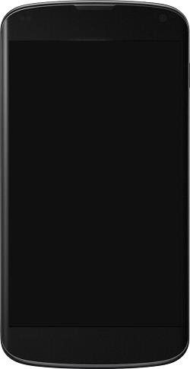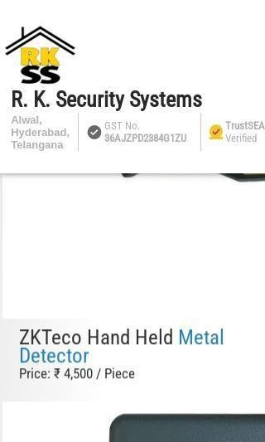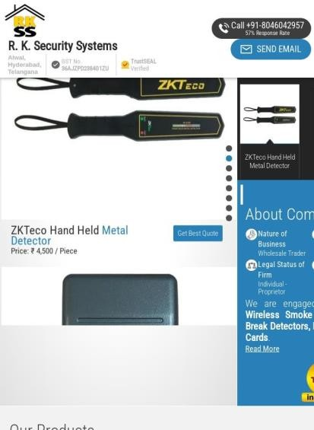

## Google's Core Web Vitals

Google is indicating that they do not have 'su cient real-world speed data for this page' in order to make a Core Web Vitals assessment. This can occur for smaller websites or those that are not crawl- able by Google.

## Use of Mobile Viewports

Your page speci es a viewport matching the device's size, allowing it to render appropriately across devices.

## Google's PageSpeed Insights - Mobile

Google is indicating that your page is scoring poorly on their Mobile PageSpeed Insights evaluation.

Note that this evaluation is being performed from US servers and the results may di er slightly from an evaluation carried out from Google's PageSpeed Web Interface as that reporting localizes to the region in which you are running the report.

Google has indicated that the performance of a webpage is becoming more important from a user and subsequently ranking perspective.



**72**

Lab Data Value Opportunities Estimated Savings

First Contentful Paint

2.1 s

Reduce unused JavaScript 0.75 s

Speed Index 2.7 s

Largest Contentful Paint

2.5 s

Time to Interactive 5.8 s

Eliminate render-blocking resources

Avoid multiple page redirects 0.63 s

0.71 s

Total Blocking Time

0.82 s

Cumulative Layout Shift 0.014

## Google's PageSpeed Insights - Desktop

Google is indicating that your page is scoring poorly on their Desktop PageSpeed Insights evaluation.

Google has indicated that the performance of a webpage is becoming more important from a user and subsequently ranking perspective.



**85**

Lab Data Value Opportunities Estimated Savings

First Contentful Paint 0.8 s

Eliminate render-blocking

0.21 s

Preload Largest Contentful Paint 0.36 s image

Speed Index 0.9 s

Largest Contentful Paint 2.1 s

Time to Interactive 2 s

resources

Total Blocking Time 0.04 s

Reduce unused JavaScript 0.19 s

Cumulative Layout Shift 0.138

Avoid multiple page redirects 0.19 s

## Flash Used?

No Flash content has been identi ed on your page.

## iFrames Used?

Your page appears to be using iFrames.

iFrames are discouraged as they can complicate navigation of content in mobile and have historically been harder to index for search engines.

## Favicon

Your page has speci ed a favicon.

## Email Privacy

No email addresses have been found in plain text on your page.

## Legible Font Sizes

There is some text on your page that is small and may not be legible enough for particular users.

We recommend reviewing all text on your page in di erent devices to ensure that it is of appropriate size.

## Tap Target Sizing

Some of the links or buttons on your page may be too small for a user to easily tap on a touchscreen. Consider making these tap targets larger to provide a better user experience.

# Performance Results

## Your performance is good



**A-**

Your page has performed well in our testing meaning it should be reasonably responsive for your users, but there is still room for improvement. Performance is important to ensure a good user experience, and reduced bounce rates (which can also indirectly a ect your search engine rankings).

## Page Speed Info

Your page loads in a reasonable amount of time.

Server Response All Page Content Loaded All Page Scripts Complete

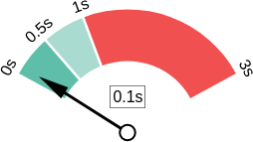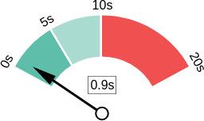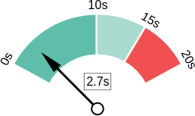

## Download Page Size

Your page's le size is reasonably low which is good for Page Load Speed and user experience.

Download Page Size Download Page Size Breakdown

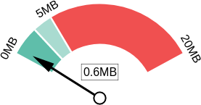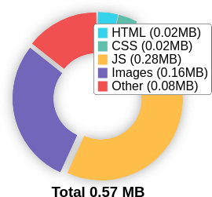

## Website Compression (Gzip, Deflate, Brotli)

Your website appears to be using a reasonable level of compression.

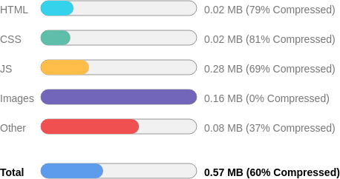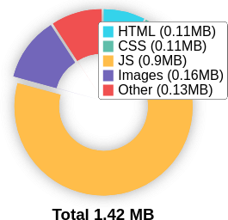Compression Rates Raw Page Size Breakdown

## Number of Resources

This check displays the total number of les that need to be retrieved from web servers to load your page.



|  |  |  |  |  |  |  |
| --- | --- | --- | --- | --- | --- | --- |
|  |  |  |  |  |  |  |
| **49** | **5** | **14** | **4** | **21** | **5** |
|  | Total Objects | Number of HTML Pages | Number of JS Resources | Number of CSS Resources | Number of Images | Other Resources |

## Google Accelerated Mobile Pages (AMP)

This page does not appear to have AMP Enabled.

## JavaScript Errors

Your page is not reporting any JavaScript errors.

## HTTP2 Usage

Your website is using an outdated HTTP protocol.

We recommend enabling HTTP/2+ or protocol for your website as it can signi cantly improve page load speed for users.

## Optimize Images

All of the images on your page appear to be optimized.

## Minification

All your JavaScript and CSS les appear to be mini ed.

## Deprecated HTML

No deprecated HTML tags have been found within your page.

## Inline Styles

Your page appears to be using inline styles.

Inline styles are an older coding practice and discouraged in favor of using CSS style sheets, due to their ability to degrade page load performance and unnecessarily complicate HTML Code.

Social Results



**F**

## Facebook Connected

**Your social needs improvement**

You appear to have a weak social presence or level of social activity (or we may just not be able to see your pro les!). Social activity is important for customer communication, brand awareness and as a marketing channel to bring visitors to your website. We recommend that you list all of your pro les on your page for visibility, and begin to build a following on those networks.

No associated Facebook Page found as a link on your page.

## Facebook Open Graph Tags

Your page is using Facebook Open Graph Tags.

## Facebook Pixel

We have not detected a Facebook Pixel on your page.

Facebook's Pixel is a useful piece of analytics code that allows you to retarget visitors if you decide to run Facebook Ads in future.

## Twitter Connected

No associated Twitter pro le found as a link on your page.

## Twitter Cards

Your page is using Twitter Cards.

## Instagram Connected

**Twitter Activity **

No associated Twitter pro le found as a link on your page.



No associated Instagram pro le found linked on your page

## LinkedIn Connected

Your page has a link to a LinkedIn pro le.

## YouTube Connected

No associated YouTube channel found linked on your page.

## YouTube Activity

No associated YouTube channel found linked on your page.

Local SEO

## Local Business Schema

Local Business Schema identi ed on the page.

LocalBusiness

## Google Business Profile Identified

A Google Business Pro le was identi ed that links to this website.



R K Security System

## Google Business Profile Completeness

The important business details are present on the Google Business Pro le.

Address Shop No 12, Matu Ram Colony, Industrial Area, Fatehabad, Haryana 125050

Phone +91 80 4604 2957

Site https://[www.rksecuritysystems.co.in/](http://www.rksecuritysystems.co.in/)

## Google Reviews

Your Google Business Pro le has a low rating or low number of reviews.

Technology Results

## Technology List

These software or coding libraries have been identi ed on your page.

Technology Version



Google Analytics

 jQuery



Nginx



OpenResty 1.13.6.2



YouTube

## Server IP Address

34.66.135.39

## DNS Servers

ns3.registry.in ns1.registry.in ns5.registry.in ns6.registry.in ns2.registry.in ns4.registry.in

## Web Server

openresty/1.13.6.2

## Charset

text/html; charset=UTF-8



### 

[https://www.thepatternscompany.com](https://www.thepatternscompany.com/)

**The Purpose of a Business is to create a Customer Who Creates Customer’s**

**Thank you**

### 